**Assignment no:1**

**Installing Tomcat**

Open your browser and head over to [https://tomcat.apache.org](https://tomcat.apache.org/).  
Scroll down a little bit to locate and click on the Tomcat 9 link located within the left menu bar. <https://tomcat.apache.org/download-90.cgi>

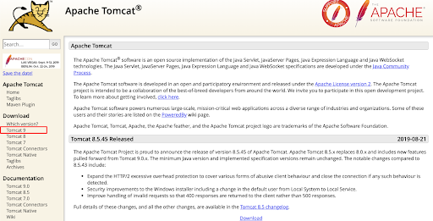

Next, locate the 32-bit/64-bit Windows Service Installer link and click on it. <https://www-eu.apache.org/dist/tomcat/tomcat-9/>

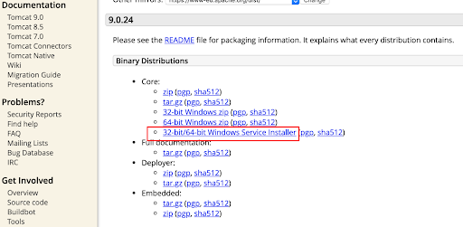

This link will open the Windows Service Installer automatically. Once the installer window pops up, you will initiate the install by clicking on the Start Download button. Once the download completes, double click the .exe installer to begin the installation.

The install wizard should only take a few moments to complete. After the install wizard has finished, it will ask you to make a few different decisions along the way.   
  
Below are the following choices you will be asked to make to install Tomcat 9.   
  
Please note you can configure tomcat9 how you would like but for the purpose of this demonstration, we will be installing it with default settings.

**Installation**

**Step 1.**

The first page of the install explains what the installer will do and what to expect. Go ahead and click Next on the first page.

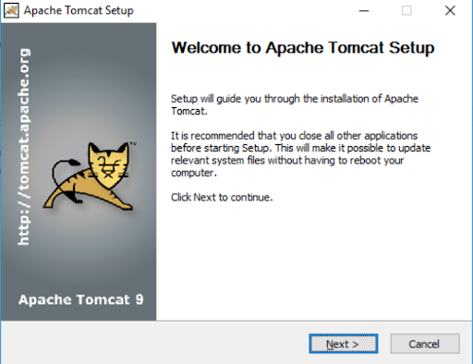

**Step 2.**

Before you can start the install, you must agree to the Apache License Agreement for the tomcat 9 service

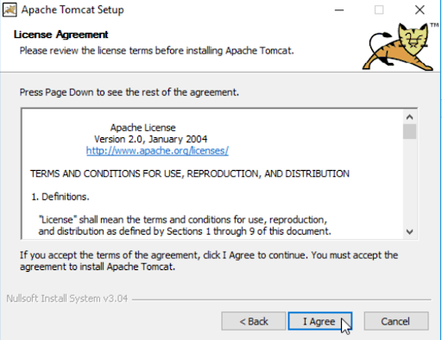

**Step 3.**

Click on “Select the type of install” dropdown list and choose the “[Full](https://www.liquidweb.com/kb/how-to-install-oracle-java-8-on-ubuntu-14-04-lts/)” install option and then click Next.

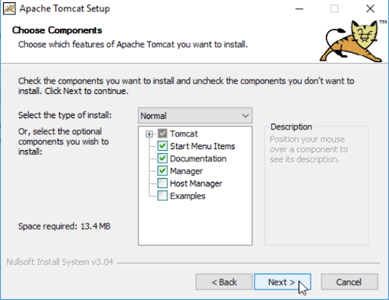

**Step 4.**

The next screen is the configuration screen. This screen will allow you to set up any default ports that you want the service to connect through, and will also allow you to set an Administrator username and password.   
  
Please note that you can configure these settings later if you choose to.   
Choose your selections and click Next.

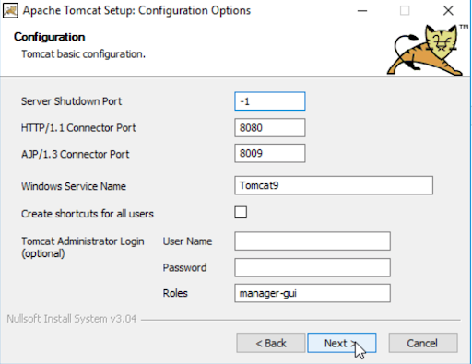

**Step 5.**

Next, you will choose the location where you want to install the tomcat9 service. Click Next.

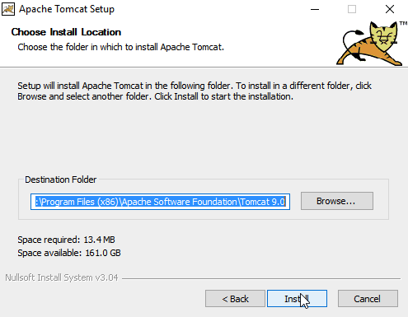

**Step 6.**

To correctly install Tomcat 9 on your server, the Wizard will want you to choose the location of any other Java related software on your server.

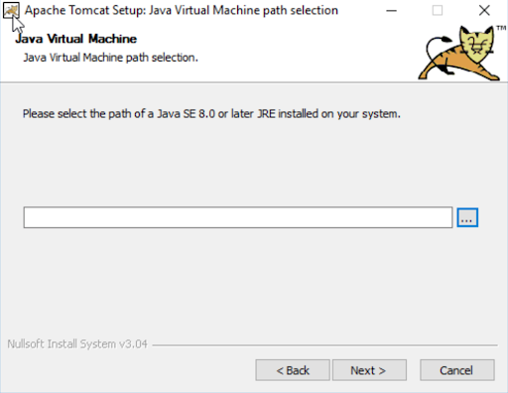

**Step 7.**

Once the install is complete, click Next.

Lastly, uncheck the Readme checkbox.   
  
If you prefer to start Apache tomcat9 after the install, leave the checkbox marked. If not, then you will want to uncheck that checkbox.

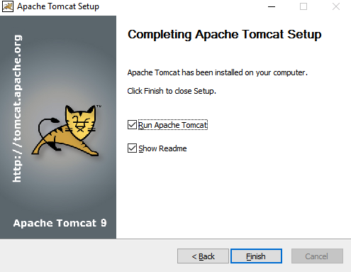

To make sure the service is running, go to the Windows startup menu and type services.cmd. From the list of available services, find the Apache Tomcat 9 service, right-click on the service name, select Start, and make sure the service starts successfully. You should see a “running” status next to the service name.

To test the Tomcat 9 install and verify it is running on your server, open and point your browser to localhost:8080 (or whatever custom port you put into the configuration).

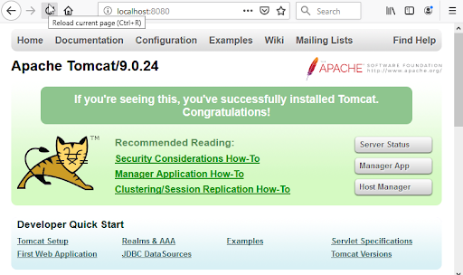

The page that loads will tell you if Tomcat 9 was successfully installed.